原文:https://www.jianshu.com/p/cb05698a1968

如何裁剪so文件:
复制如下片段到build.gradle中
android {
...
splits {
abi {
enable true
reset()
include 'x86', 'x86_64', 'armeabi-v7a', 'arm64-v8a'
//select ABIs to build APKs for
universalApk true
//generate an additional APK that contains all the ABIs
}
}

// map for the version code
project.ext.versionCodes = ['armeabi': 1, 'armeabi-v7a': 2, 'arm64-v8a': 3, 'mips': 5, 'mips64': 6, 'x86': 8, 'x86_64': 9]

android.applicationVariants.all { variant ->
// assign different version code for each output
variant.outputs.each { output ->
output.versionCodeOverride =
project.ext.versionCodes.get(output.getFilter(com.android.build.OutputFile.ABI), 0) * 1000000 + android.defaultConfig.versionCode
}
}
}
生成apk如下图
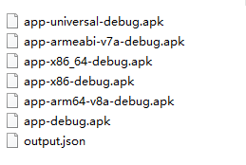

通过在adb shell中输入
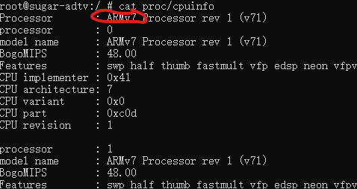
可以查看cpu架构为哪一个,做对应安装

